3CD Mathematics Specialist WACE Revision

Complex Numbers
Questions are taken from VCE Secondary Papers

2009

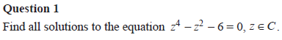
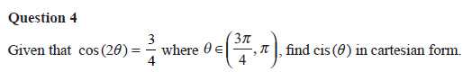

Answers
1.
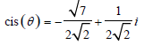
4.

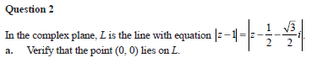
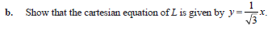

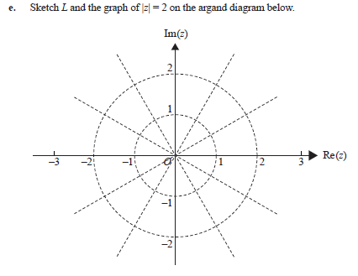

Answers
2. a.

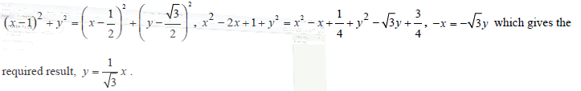
b.

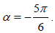
c.
d.

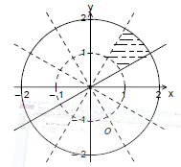
e.

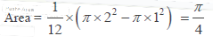
f.

2008

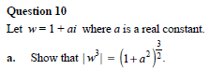

Answers
10. b.
c.

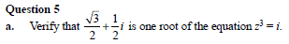
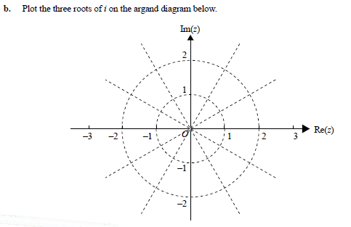
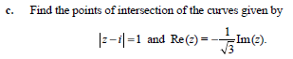
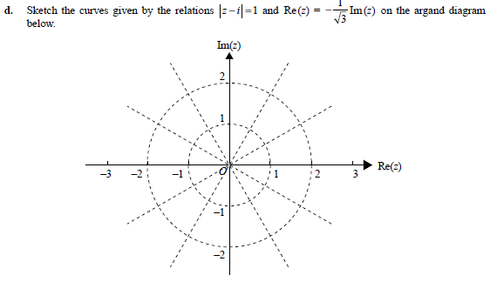
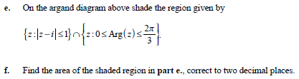

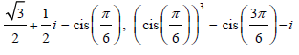
Answers

5. a.

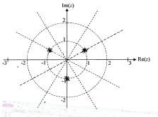
b.

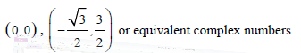

c.

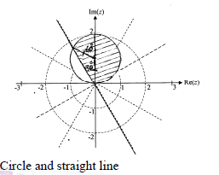
d.

e.

f.

2007

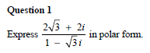

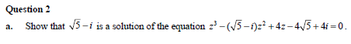

Answers
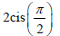
1. 2. b.

2006
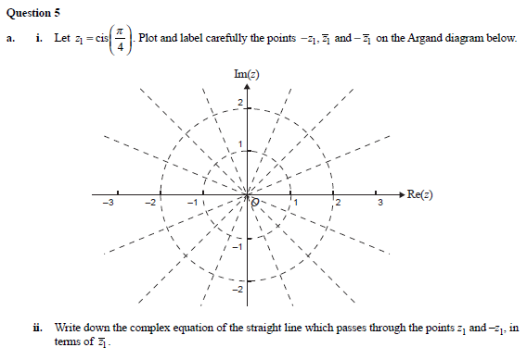
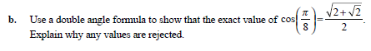
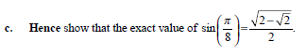
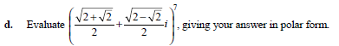
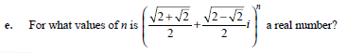
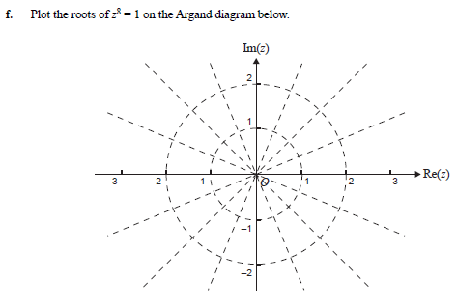

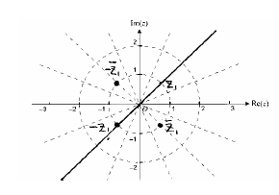
Answers
5. a. i. ii.

b.
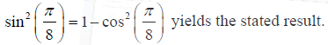
c.
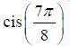
d.
e.
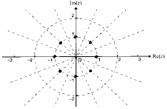
f.

